**Project Overview**

This project aims to analyse the **Calgary Housing Market** using available open-source data to derive actionable insights for real estate professionals. The goal is to understand trends related to property investment opportunities, affordability, rental demand, and tax implications in Calgary's housing market.

**Purpose and Goals**

The purpose of the study is to provide comprehensive data-driven insights for:

1. **Real Estate Agents**: Offering detailed market analysis to better guide clients.
2. **Urban Planning**: Supporting decision-makers with data for strategic city development.
3. **Property Tax**: Helping individuals and agents understand trends in property tax and financial planning.

The overall objective is to empower stakeholders (real estate agents, investors, urban planners) to make informed decisions, particularly around property sales, tax strategy, and urban investments.

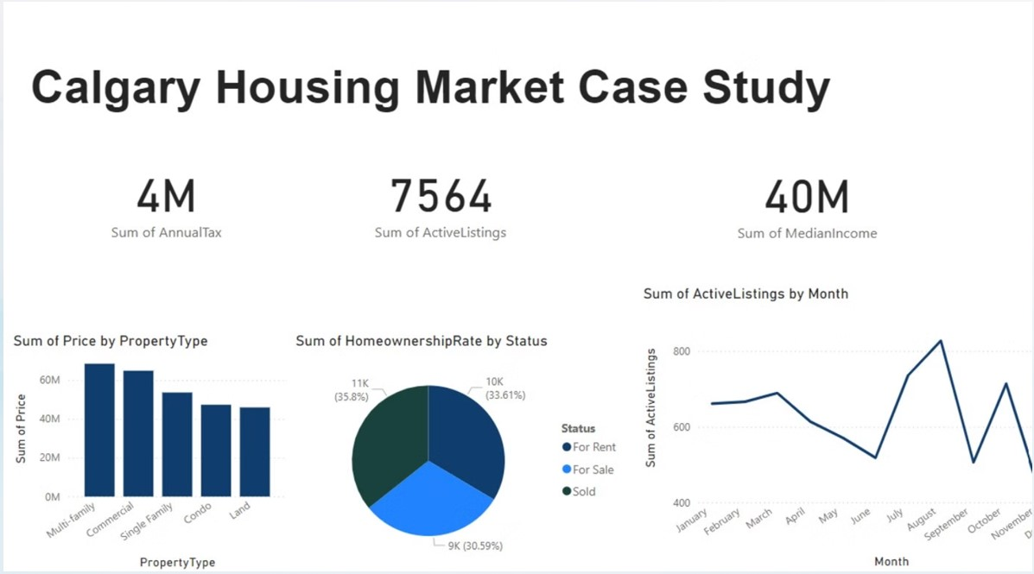

# **Dashboard Overview**

# **The dashboard displays various statistics and visualizations related to housing in Calgary:**

**Key Figures**

4M: Sum of Annual Tax

7564: Sum of Active Listings

40M: Sum of Median Income

**Bar Chart**

Sum of Price by Property Type: Multi- family properties have the highest price sum, followed by commercial properties, single-family homes, condos, and land.

**Pie Chart**

Sum of Homeownership Rate by Status: 35.8% (11K) are for rent, 33.61% (10K) are for sale, and 30.59% (9K) are sold.

**Line Graph**

Sum of Active Listings by Month: Shows fluctuations throughout the year, with a peak in the summer months (July and August) and a dip in the fall (December).

**Key Research Questions**

The study focuses on addressing three key questions:

1. **What trends can be identified from the sum of active listings by month?**
   * By analysing how the number of active listings changes month-to-month, the study explores the impact of seasonal fluctuations and market trends. For example, do more listings occur in the spring and summer compared to the winter months?
2. **What strategic recommendations can be offered based on key metrics (KPI data)?**
   * Using the provided metrics, the team can advise real estate agents and investors on property purchase timing and areas for investment based on tax trends, active listings, and market conditions.
3. **What insights can be derived from homeownership rates in Calgary?**
   * The study examines areas with varying levels of homeownership versus rental occupancy, offering agents targeted insights on whether to focus on buyers or renters in certain neighbourhoods.

**Key Performance Indicators (KPIs)**

The following KPIs are defined to track the operational and strategic objectives of the study:

1. **Sum of Annual Tax**: Indicates the total property tax collected in the Calgary market, helping clients identify areas with more favourable tax rates for property investments.
2. **Sum of Active Listings**: Reflects the market’s supply conditions, allowing stakeholders to discern between a buyer’s or seller’s market at various times of the year.
3. **Sum of Median Income**: Provides a measure of affordability, helping real estate agents match properties to clients’ budgets based on median income levels in different areas.

**Data Model**

The data used for the analysis was sourced from open datasets on Calgary’s housing market. The primary data categories analysed include:

* Property prices by type (e.g., single-family homes, multi-family units, commercial properties).
* Homeownership status (for rent, for sale, sold properties).
* Monthly active listings.

**Results**

**Active Listings by Month**

* There is a clear seasonal trend, with the number of listings increasing in the summer months (July and August), peaking at around 800 listings, and decreasing in the fall (October).
* This indicates that the summer months are the best time for buyers, as the market offers more options, whereas the fall is slower in terms of listings.

**Price Trends by Property Type**

* **Multi-family** and **commercial properties** show the highest total price sums (around 60 million), followed by single-family homes. Condos and land have lower total price sums but still represent significant investment opportunities.
* These trends highlight the relative value of different property types in the market, with multi-family properties offering high returns.

**Homeownership Rate**

* A nearly equal split between properties **for rent (35.8%)**, **for sale (33.61%)**, and **sold (30.59%)** suggests a balanced housing market, with demand for both rental and ownership properties.
* Agents can focus on advising clients based on whether their focus is on buying, selling, or renting, depending on the market dynamics.

**Conclusions**

* **Seasonal Listing Trends**: Summer is the most active period for property listings, and both buyers and sellers should take advantage of this peak period. Real estate agents can plan their marketing strategies accordingly.
* **Balanced Market for Renting and Buying**: With nearly equal parts of the market available for rent, sale, and sold, there is opportunity for both buyers and renters. The market appears balanced in terms of demand for ownership and rental properties.
* **Investment Potential**: Multi-family and commercial properties are the most valuable in terms of total price, making them attractive for investors seeking high returns. Emerging neighbourhoods offer strong growth potential.